**Growing CoDesign Tekniske Instruktioner**

**Backup / Kopier SD Kort styresystem:**

<https://computers.tutsplus.com/articles/how-to-clone-your-raspberry-pi-sd-cards-with-windows--mac-59294>

**Aktiver SSH:**

[**https://github.com/DDlabAU/raspberry-pi/blob/master/raspberry-pi-ssh-fjernstyring/README.md**](https://github.com/DDlabAU/raspberry-pi/blob/master/raspberry-pi-ssh-fjernstyring/README.md)

**Installer Processing til Pi:**

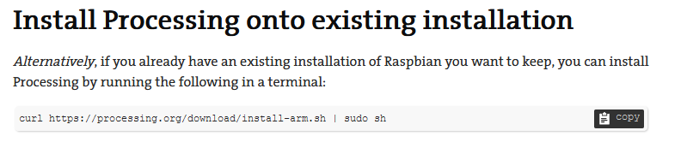

curl https://processing.org/download/install-arm.sh | sudo sh

**Hent Processing sketch fra github:**

Git clone <https://github.com/duendue/growing-codesign.git>

**Setup audio:**

**<https://www.raspberrypi.org/documentation/configuration/audio-config.md>**

**Installer driver til Skærm:**

**sudo rm -rf LCD-show  
git clone** [**https://github.com/goodtft/LCD-show.git**](https://github.com/goodtft/LCD-show.git) **chmod -R 755 LCD-show  
cd LCD-show/  
sudo ./LCD35-show**

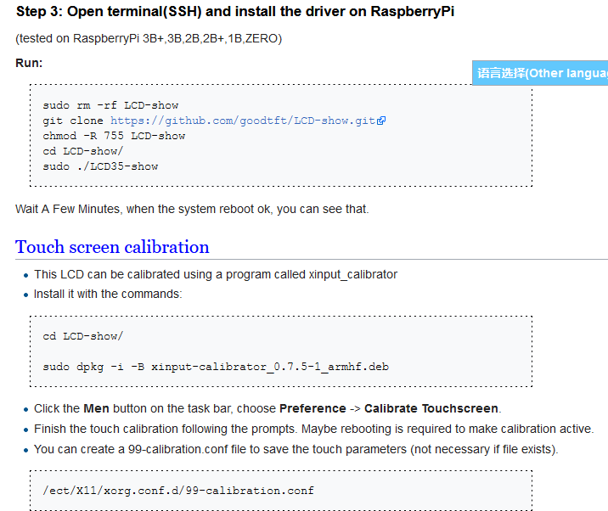

**Skift mellem lille skærm og HDMI skærm:**  
OBS: I stedet for at skrive ***sudo ./mpi3508-show*** skal du skrive ***sudo ./lcd35-show 180*** da vi bruger en anden skærm!

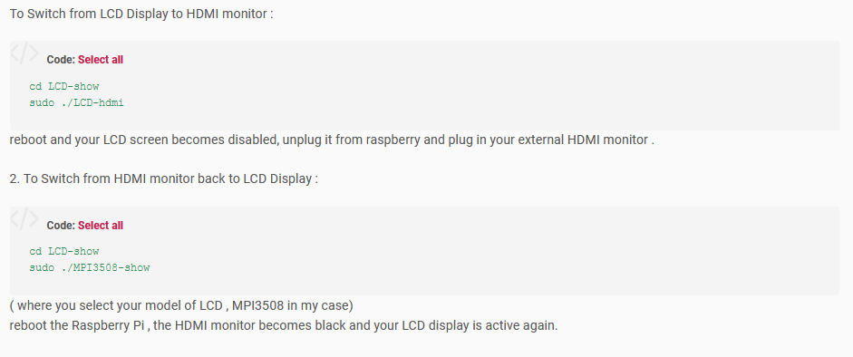  
  
**Sæt sketch til at køre automatisk når pi tændes:**

